Name: _________________

Date: ___________

**The Food Chain Activity Page**

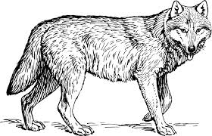Circle whether the animal or plant is a consumer, producer or decomposer.

**Hint:** decomposers go here!

Consumer or Producer or Decomposer

Consumer or Producer or Decomposer

Consumer or Producer or Decomposer

Consumer or Producer or Decomposer

Consumer or Producer or Decomposer

Consumer or Producer or Decomposer

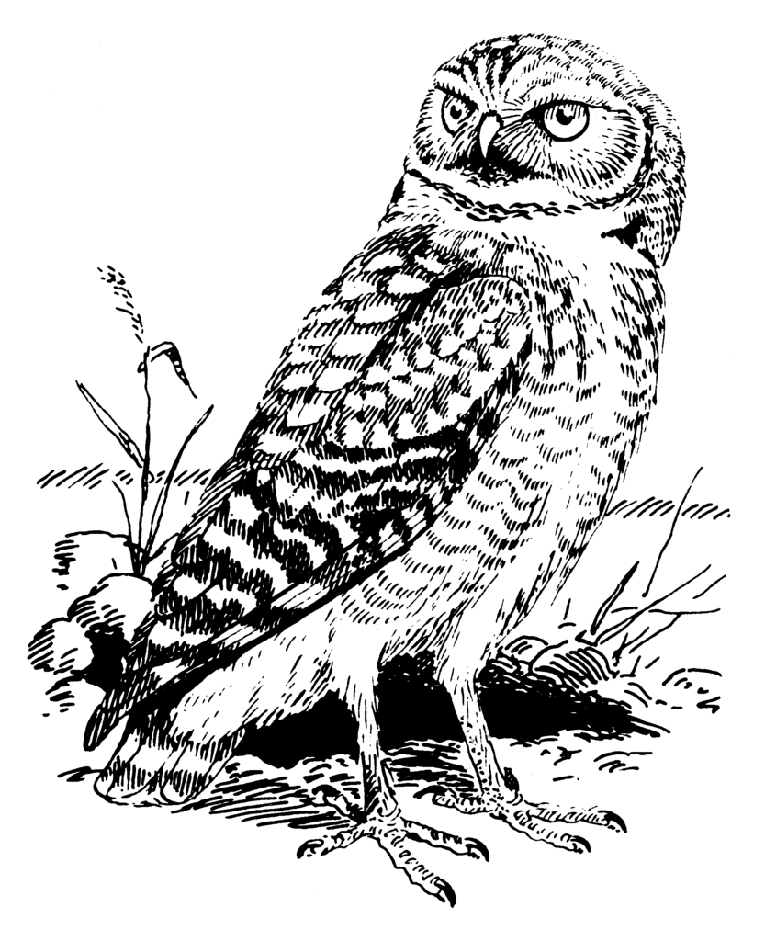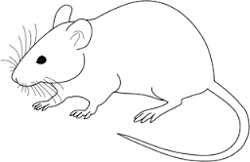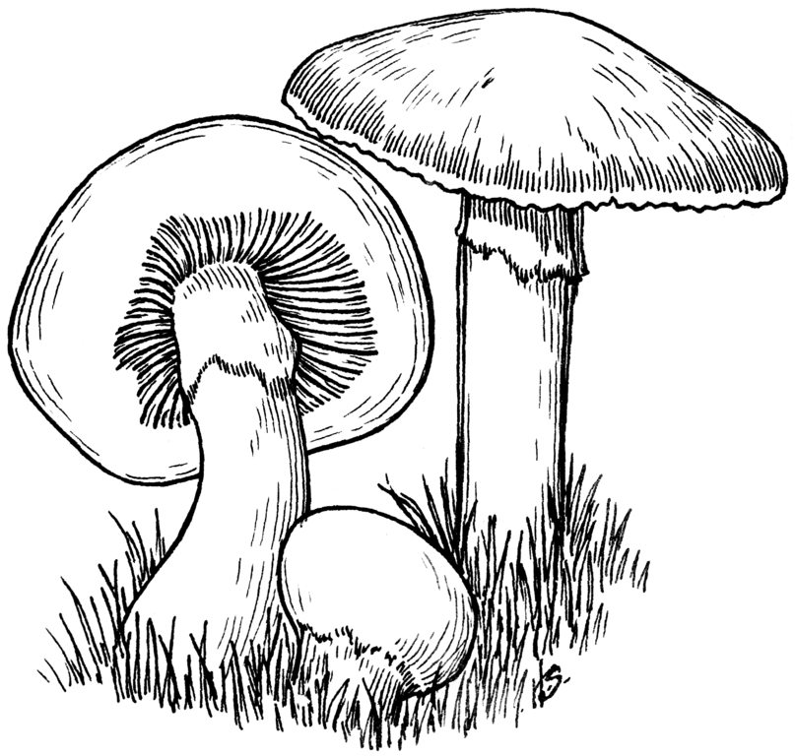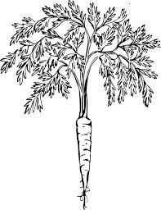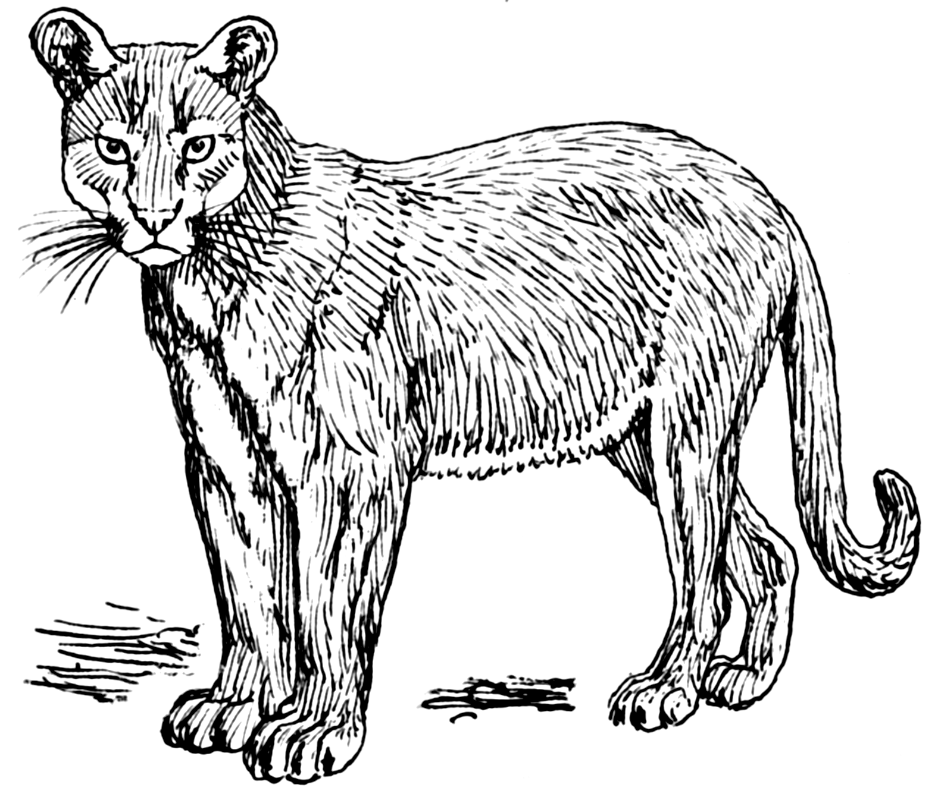Draw an arrow to the food chain line to determine where the respective animal goes.