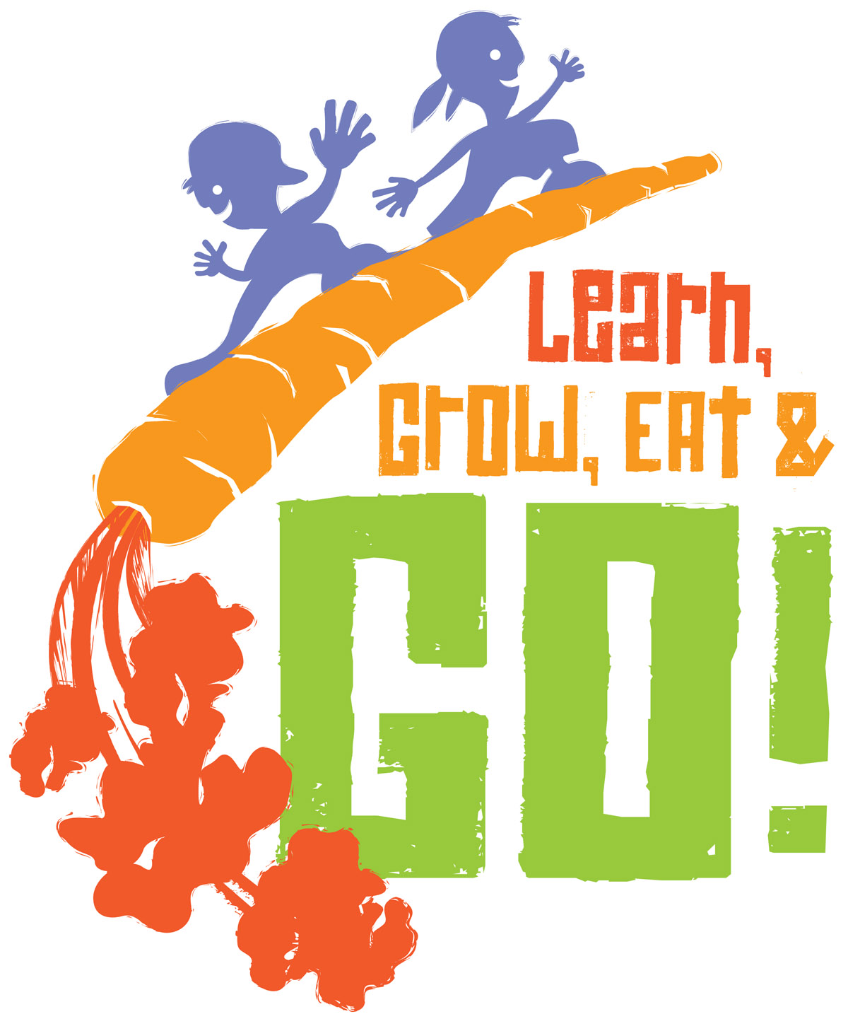
2015 (insert) County Learn, Grow, Eat & GO!
Agent Name, Agent Position,
_______ County

An interdisciplinary approach to reducing child obesity through the Learn, Grow, Eat & GO! curriculum (a modification/revision of the Junior Master Gardener “Nutrition in the Garden”), Walk Across Texas, and the Coordinated Approach to Child Health program.

Relevance
The high prevalence of childhood obesity in Texas is cause for concern because it is linked to negative health consequences for children and their families. Schools are uniquely positioned to have a positive impact on children’s knowledge and behaviors associated with obesity. For example, vegetable exposure plus school gardening has been shown to improve consumption of fruits and vegetables. Adding more frequent and more vigorous physical activities during school has been shown to improve student fitness and weight. The home environment is also an important influence on a child’s eating and activity behaviors. The greater the frequency of vegetable consumption and physical activity by parents, the greater the consumption of these foods and exercise by their children. With child obesity rates among low-income children in Texas ranging from 10% to over 20%, engaging schools and families in prevention efforts is critical.

Response
The Learn, Grow, Eat & GO! (LGEG) curriculum emphasizes science, math, language art/reading, social studies and health through effective learning activities with both the LGEG and WAT programs. The LGEG curriculum was designed to engage children and their families in school gardens, vegetable recipe tastings, classroom activities and take home family stories; therefore, the curriculum includes:
- Classroom raised bed or container garden
- Classroom vegetable tastings and food demonstrations
- Family stories for students to take home
- Option for the students to become LGEG certified through the JMG program
- Opportunities for “Growing Strong” section
  - Walk Across Texas online team enrollment
  - Family physical activity newsletters
  - Family physical activity bonus miles
  - Physical activity walking BINGO
  - Classroom “physical activity breaks” related to school subjects

County agents partnered with (insert appropriate partners like: school districts, SHAC’s, elementary schools, afterschool centers, or summer programs) to train (insert who was trained: teachers, school staff, and center staff) on how-to implement LGEG. Volunteers were also recruited and utilized to help implement the program by (insert how volunteers and partners helped: provide incentives or educational programs, assist with programming and implementation. Extension volunteer groups, like Master Gardeners and Master Wellness Volunteers, as well as school volunteers, can be trained and utilized for assisting with school gardens, food demonstrations, and curriculum activities.)

Results
Texas A&M AgriLife Extension Service in (insert) County partnered with (insert) Independent School District to implement the Learn, Grow, Eat & GO! curriculum in (#) of (grade) classes at (school name/s).
- (%) of student participants were female and (%) were male.
- (%) were Hispanic, (%) were Caucasian, (%) were African-American, and (%) listed other.

Nutrition: Extension personnel and teachers led 6 raw vegetable tastings and food demonstrations to increase child preference. Child preference for vegetables is a high indicator for consumption of vegetables.
- On the pre-activity evaluation, the average number of vegetables students had tried was (insert) and the average number of vegetables the students liked was (insert).
- This number increased on the post-activity evaluation an average of (insert) vegetables students had tried and students reported liking an average of (insert) vegetables.
- Report if there were changes on the pre- post – to the vegetable consumption questions.

Physical Activity: Physical activity programs are implemented by Extension personal and school staff to increase student involvement in physical activities and decrease sedentary behaviors.
- Prior to the LGEG program (insert) of children indicated getting at least 30 minutes of moderate to vigorous physical activity. Following the LGEG program, the number of students getting at least 30 minutes of moderate to vigorous physical activity, increased to (insert).
- Students also indicated that they were spending less time being sedentary (watching TV, playing computers or video games) away from school. Before the LGEG program (insert) children indicated that they spent 2 or more hours watching TV or playing computer or video games, while after the program (insert) children reported spending 2 or more hours doing those sedentary activities.
- Students increased physical activity through the Walk Across Texas program. (Here you can report the total miles walked by school or class, the amount of miles parents contributed through bonus miles, and the increase in miles from week 1 to week 8)

Garden: Students participated in building, planting, maintaining, and harvesting classroom garden beds. The LGEG program invites parents to participate in the gardening project and encourages students to share their experiences at home with their families.
- On the pre-activity evaluation, the average number of students who had participated in gardening activities with their families before LGEG was (insert) and the average number of students and families participating in gardening activities after LGEG was (insert).

Knowledge Gain: Knowledge gain related to nutrition indicates self-efficacy to choose the healthiest drink choices.
Below are students responses to, “If I could choose, I would rather drink…”
 | Pre - LGEG |  | Post - LGEG
Fruit Juice or Water | (insert) chose Fruit Juice | (insert) chose Water | (insert) chose Fruit Juice | (insert) chose Water
Soda or Fruit Juice | (insert) chose Soda | (insert) chose Fruit Juice | (insert) chose Soda | (insert) chose Fruit Juice
Water or Sports Drink | (insert) chose Water | (insert) chose Sports Drink | (insert) chose Water | (insert) chose Sports Drink

What schools are saying…
- Include statements from teachers, principals, or students about the impact of the program

