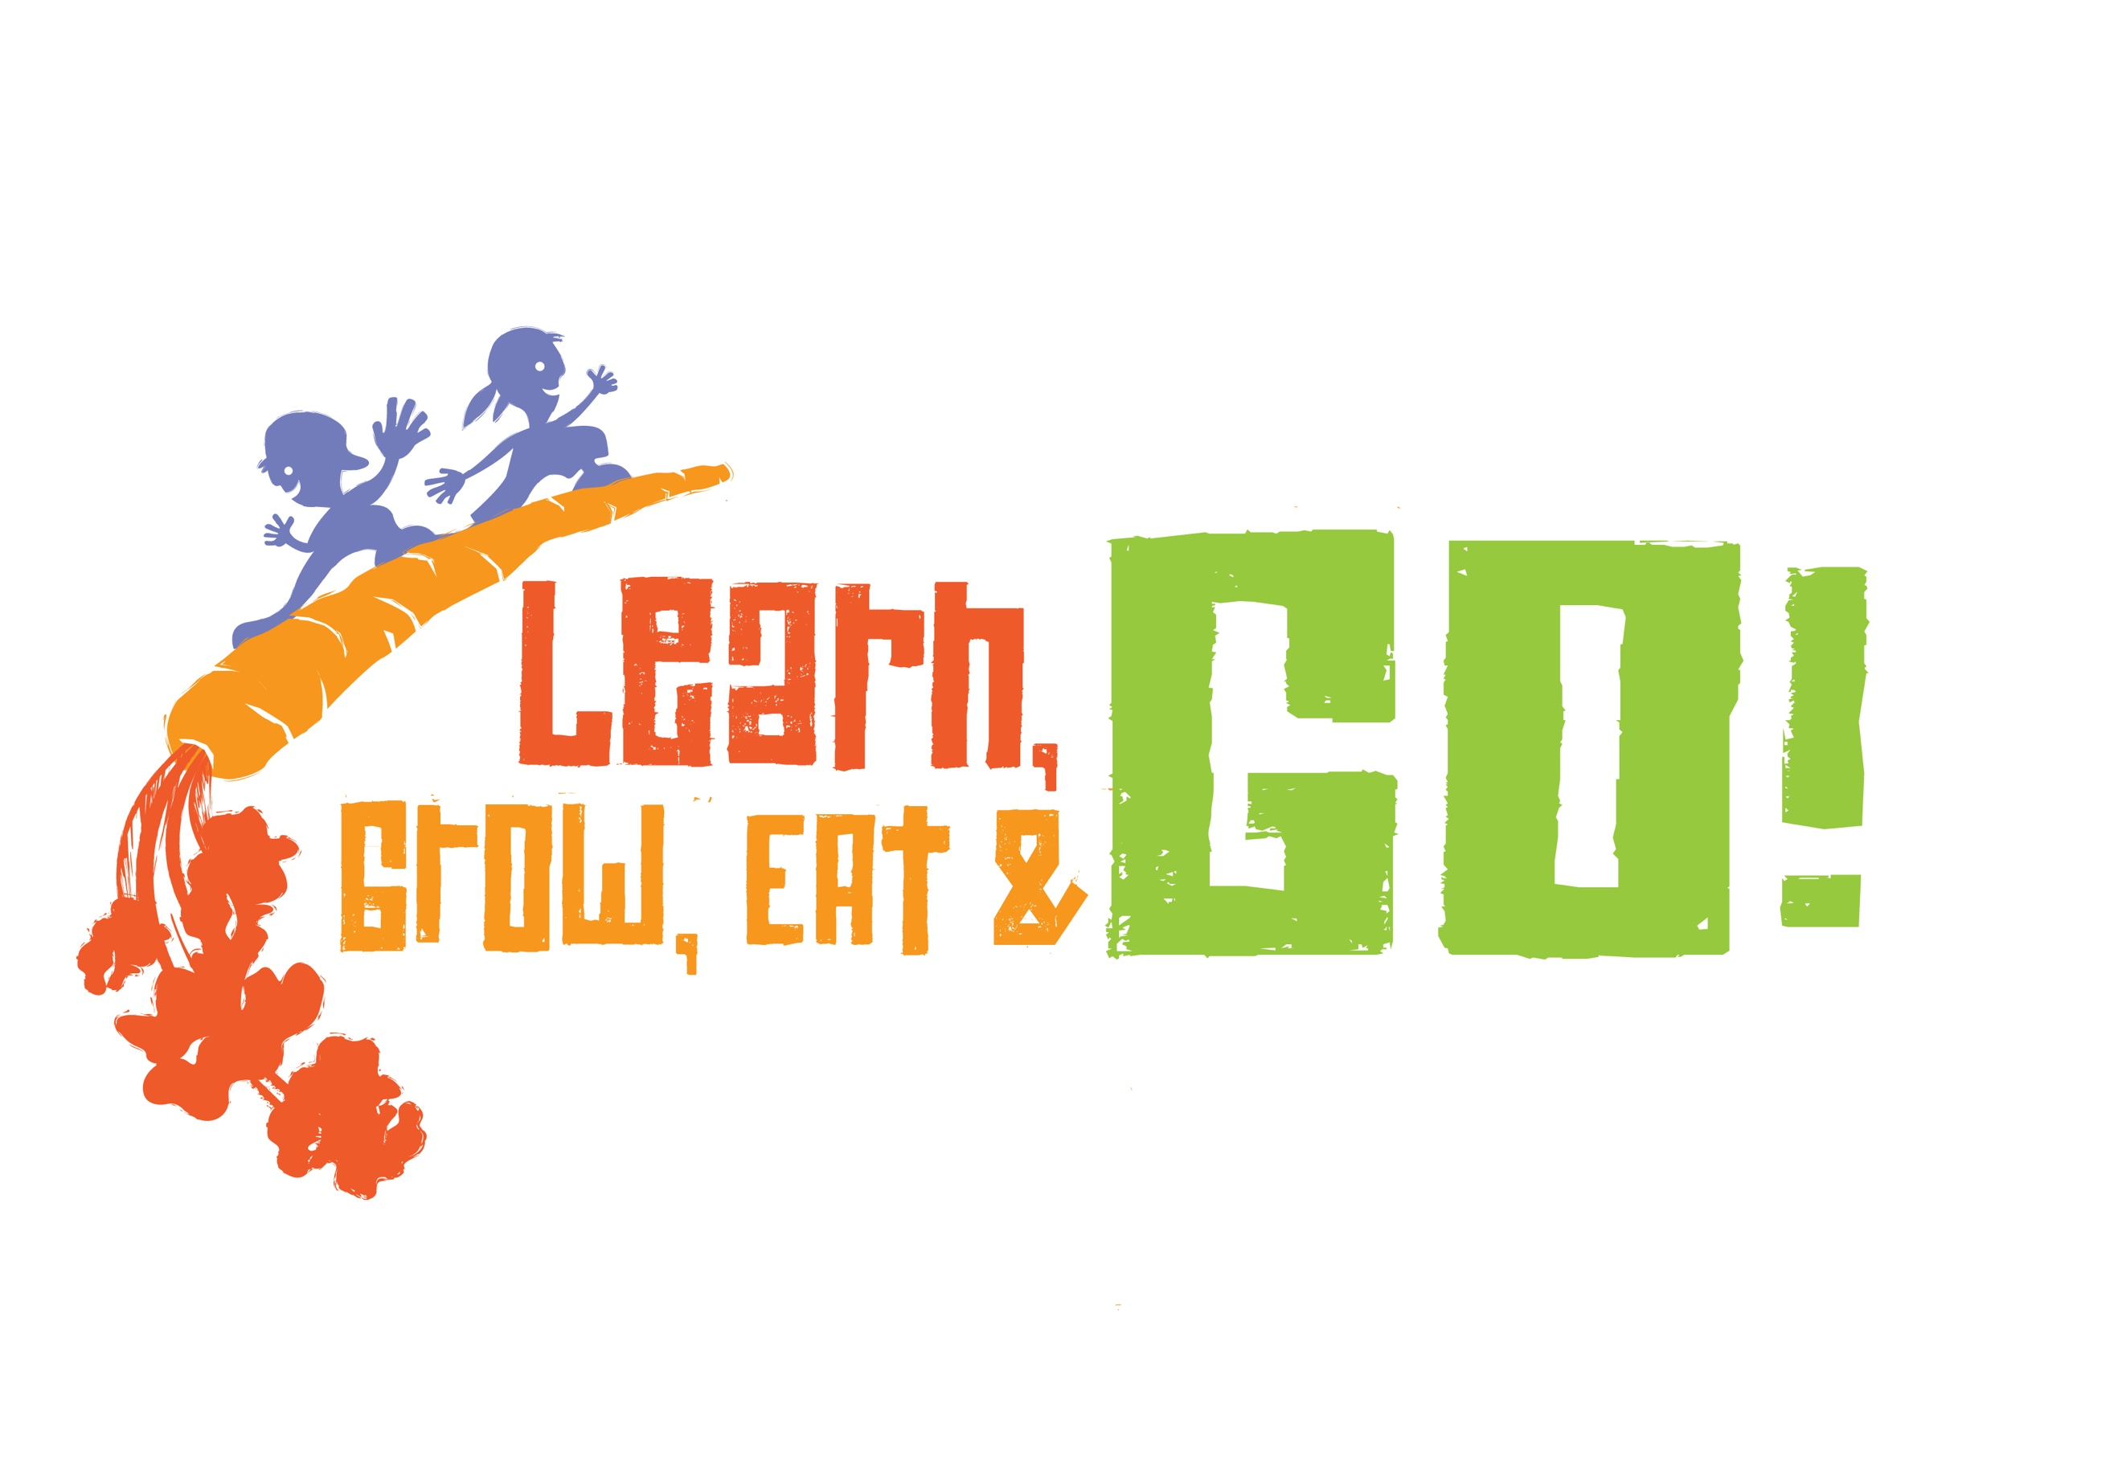

FOR MORE INFORMATION ON THE

LEARN! GROW! EAT! & GO! PROGRAM:

<insert county office contact information>

Or add training event information

Learn! Grow! Eat! & Go! Curriculum provides 10 concepts of instruction that emphasize Science, Math, Language Arts/Reading, Writing, Social Studies, Physical Education, Health, Horticulture, and Nutrition all with a solid correlation to the Texas Essential Knowledge and Skills (TEKS) standards.

* Total number of TEKS: 99
* Total number of TEKS eligible for STAAR testing: 36
* Total number of TEKS eligible for STAAR testing as Readiness Standards: 16
* Total number of TEKS eligible for STAAR testing as Supporting Standards: 20
* Positive health outcomes
* Highly engaging activities
* Linked to grade level readiness and preparedness at current and future grade levels
* Supports college and career readiness

Learn! Grow! Eat! & Go!

* Student, family, and volunteer engagement
* School gardens
* Physical activity
* Food tastings
* Recipe demonstrations

“We know that obesity is more common now than ever, so when we saw how excited the students were when we built the garden we knew this project was going to have a major impact on our students and community...” 3rd grade teachers

“Learn! Grow! Eat! & Go! Helped plant a seed in our minds to implement fifty gardens in fifty of our schools.” School District Program Specialist for Health and Physical Education

“LGEG is a perfect example of a wellness program that addresses a variety of interests and provides a lifelong wellness skillset… it is our hope that the students impacted by this program will continue to be wellness role models in the community.” School District Wellness Personnel