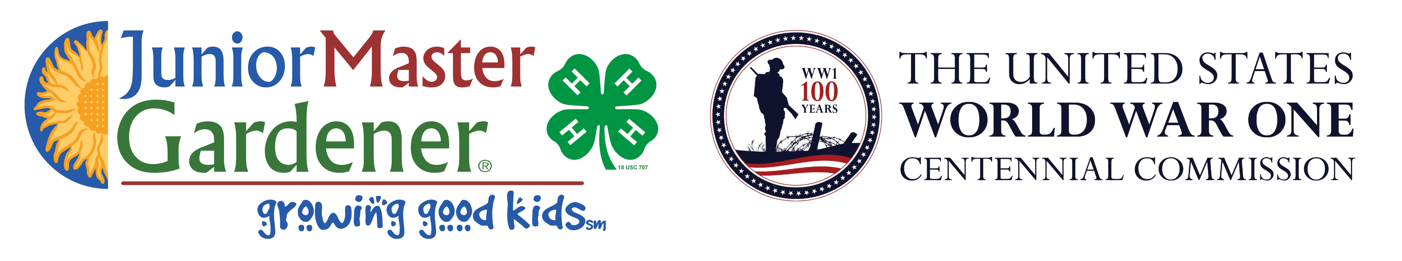

Buy poppy seeds & help us raise money for our school while
Honoring Veterans by helping
BUILD THE NATIONAL WW1 MEMORIAL

Student Name:_______________________________________________________

Grade:______________Teacher:________________________________________

This fall my school is honoring veterans with the Poppy Fundraiser Project that raises funds to both:
1. Build the National World War I Memorial in Washington, D.C.
2. AND also raise funds for my school!
The red poppy is a symbol that honors veterans and I am selling packets of red poppy seeds for $2 each. We are partnering with the WW1 Centennial Commission with this special project. More than half of the money we raise is being donated to help build World War I Memorial and the rest goes to our school to help pay for: ____________________________________________________________
Thank you for honoring veterans and for supporting our school! I will be delivering your red poppy seeds later in the fall. For information about the Poppy Fundraiser Project or how to grow your poppy seeds, go to: www.JMGkids.us/POPPY

Name: | Phone Number: | Number of Poppy Seed Packets Purchased: | Total Amount Collected:

